Họ và tên: …………Trần Gia Nguyên Phong…………………………………... MSSV: ………22002575………………….

**LAB WEEK 04: INFORMATION - PRESENTATION**

**Practice Problem 2.8**Fill in the following table showing the results of evaluating Boolean operations on bit vectors.

|  |  |
| --- | --- |
| **Operation** | **Result** |
| a | [01101001] |
| b | [01010101] |
| ~ a | 10010110 |
| ~ b | 10101010 |
| a & b | 01000001 |
| a | b | 01111101 |
| a ^ b | 00111100 |

**Practice Problem 2.9**Computers generate color pictures on a video screen or liquid crystal display by mixing three different colors of light: red, green, and blue. Imagine a simple scheme, with three different lights, each of which can be turned on or off, projecting onto a glass screen:

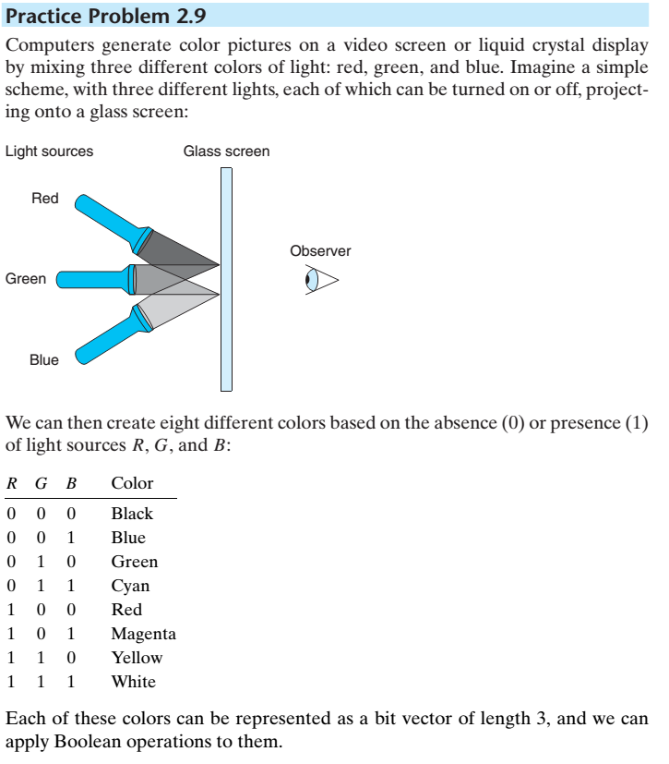  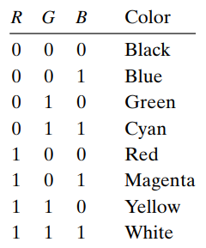

We can then create eight different colors based on the absence (0) or presence (1) of light sources R, G, and B:

Each of these colors can be represented as a bit vector of length 3, and we can apply Boolean operations to them.

1. The complement of a color is formed by turning off the lights that are on and turning on the lights that are off. What would be the complement of each of the eight colors listed above?

|  |  |  |  |
| --- | --- | --- | --- |
| R G B | Color | ~R ~ G ~B | Complement Color |
| 0 0 0 | black | 111 | White |
| 0 0 1 | Blue | 110 | Yellow |
| 0 1 0 | Green | 101 | Magenter |
| 0 1 1 | Cyan | 100 | Red |
| 1 0 0 | Red | 011 | Cyan |
| 1 0 1 | Magenta | 010 | Green |
| 1 1 0 | Yellow | 001 | Blue |
| 1 1 1 | White | 000 | Black |

1. Describe the effect of applying Boolean operations on the following colors:

|  |  |  |
| --- | --- | --- |
| Color | RGB presentation | Color |
| Blue | Green | Blue(001) | Green(010) | Cyan(011) |
| Yellow & Cyan | Yellow(110) & Cyan(011) | Green(010) |
| Red ^ Magenta | Red(100) ^ Magenta(101) | Blue(001) |
| Red | Yellow | Red(100) | Yellow(110) | Yellow(110) |
| Red & Yellow | Red(100) & Yellow(110) | Red(100) |
| Blue ^ Cyan | Blue(001) ^ Cyan(011) | Green(010) |
| Yellow | Magenta | Yellow(110) | Magenta(101) | White(111) |
| Green & Blue | Green(010) & blue(001) | Black(000) |

**Practice Problem 2.14**Suppose that x and y have byte values 0x66 and 0x39, respectively. Fill in the following table indicating the byte values of the different C expressions:

|  |  |  |  |
| --- | --- | --- | --- |
| **Expression** | **Value** | **Expression** | **Value** |
| x & y | 0x20 | x && y | 0x01 |
| x | y | 0x7F | x || y | 0x01 |
| ~x | ~y | 0xDF | !x || !y | 0x00 |
| x & !y | 0x00 | x && ~y | 0x01 |

**Practice Problem 2.16**

Fill in the table below showing the effects of the different shift operations on singlebyte quantities. The best way to think about shift operations is to work with binary representations. Convert the initial values to binary, perform the shifts, and then convert back to hexadecimal. Each of the answers should be 8 binary digits or 2 hexadecimal digits.

|  |  |  |  |  |  |  |  |
| --- | --- | --- | --- | --- | --- | --- | --- |
| x | | x << 3 | | (Logical)  x >> 2 | | (Arithmetic)  x >> 2 | |
| Hex | Binary | Hex | Binary | Hex | Binary | Hex | Binary |
| 0xC3 | 1100 0011 | 0x18 | 00011000 | 0x30 | 00110000 | 0xf0 | 11110000 |
| 0x75 | 0111 0101 | 0xA8 | 10101000 | 0x1d | 00011101 | 0x1d | 00011101 |
| 0x87 | 1000 0111 | 0x38 | 00111000 | 0x21 | 00100001 | 0xe1 | 11100001 |
| 0x66 | 0110 0110 | 0x30 | 00110000 | 0x19 | 00011001 | 0x19 | 00011001 |